**Discovery Hybrid Rheometer (DHR)** - Work Instruction

The following is a synthesis of the manuals and documentation provided by the manufacturer “TA Instruments”. Processes are amended to fit the laboratory environment at Tecnológico de Monterrey Campus Estado de México.

**History of changes:**

11Apr2019 - 1st version of the document

**Edited by:**

Antonio Osamu Katagiri Tanaka <A01212611@itesm.mx>

**Revised by:**

Nora Argelia Tafoya Medina <nuorriael@itesm.mx>

Dora Iliana Medina Medina <dora.medina@tec.mx>

Table of Contents

I. Start-up Procedure 3

II. Shutdown Procedure 8

III. Install a Geometry 11

IV. Install the Lower Stage 12

V. Remove the Lower Stage 14

VI. Instrument Calibration 16

VII. Run an Experiment 24

# Start-up Procedure

1. **Ensure** that the air supply is turned on.  
     
   **Open** the **black** ball/T valve and then the **orange** ball/T valve.  
   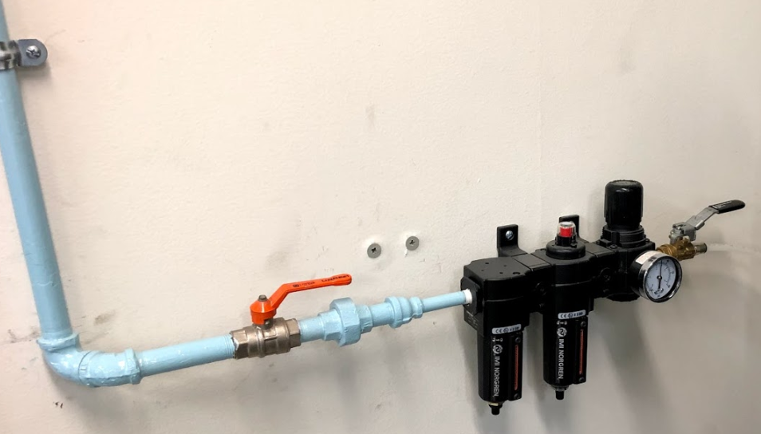  
   The valves in the figure above are in their open position  
     
   **Ensure** the gauge meter reads 30 (±2) psi-+  
   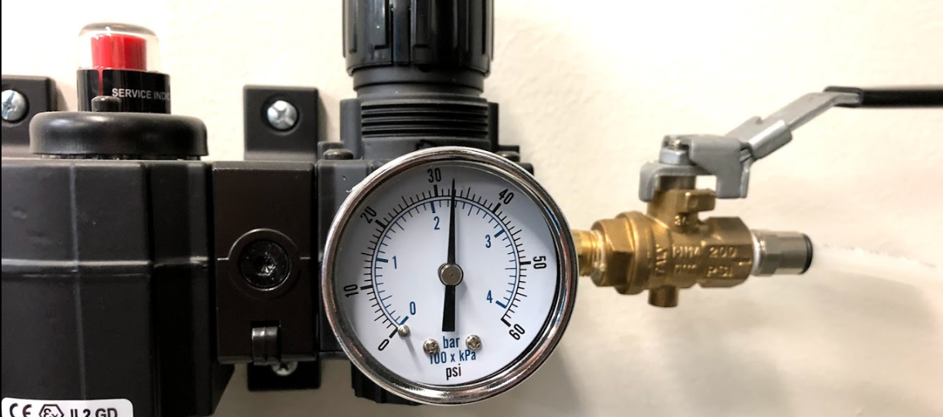  
     
   **Plug** the instruments to the orange (isolated ground) outlet  
   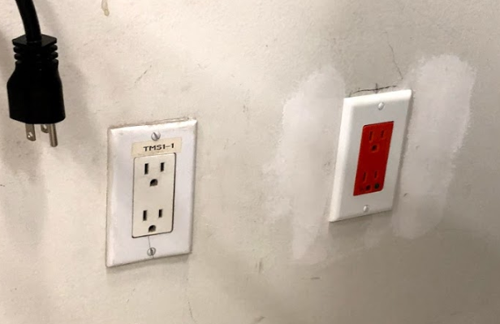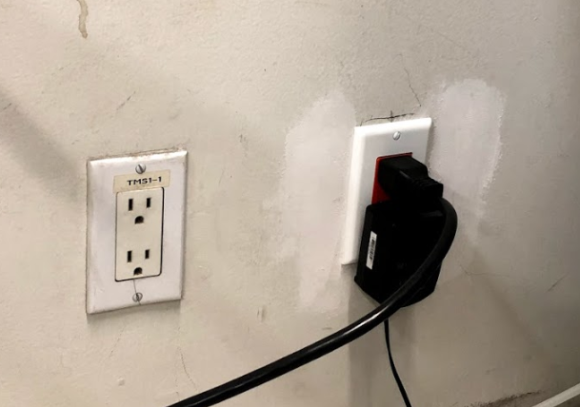
2. **Turn** on fluid circulation.  
     
   The TA-supplied Air Cooled Circulator is located below the working table, next to the isolated ground outlet  
   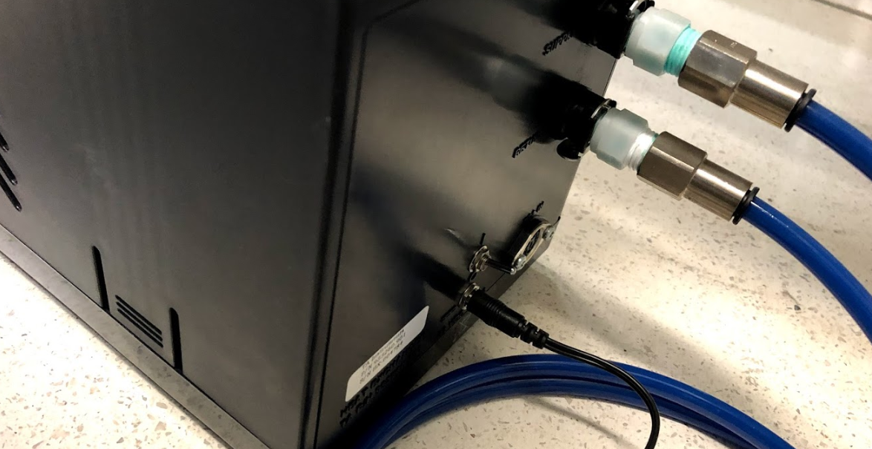  
   The switch in the DOWN position indicates the fluid circulation is OFF; similarly,  
   the switch in the UP position indicates the fluid circulation is ON.

ON/OFF switch

(in its ON position)

1. **Remove** (if fitted) the bearing clamp by holding the clamp and turning the draw rod counter clockwise  
     
   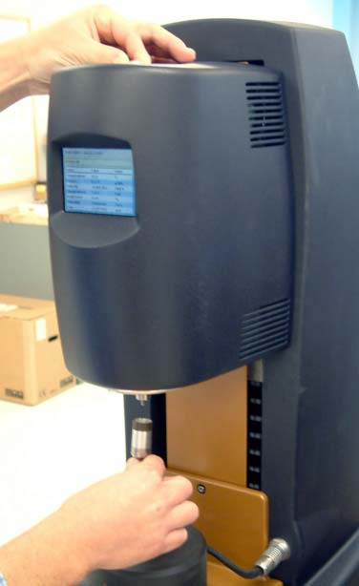  
   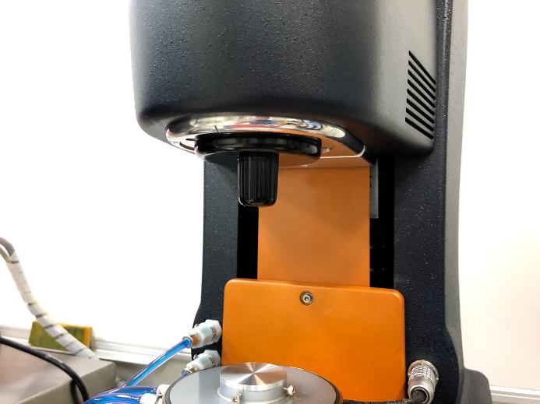  
     
   NOTE: If air supply is interrupted while bearing lock is off, **DO NOT TURN** **the DRIVE SHAFT**; this will cause damage to the radial bearing. Locate another gas source, attach it to the gas port on the rheometer, and then attach bearing lock while the radial air bearing is floating.  
    **Place** the bearing clamp at the back of the instrument’s body.  
   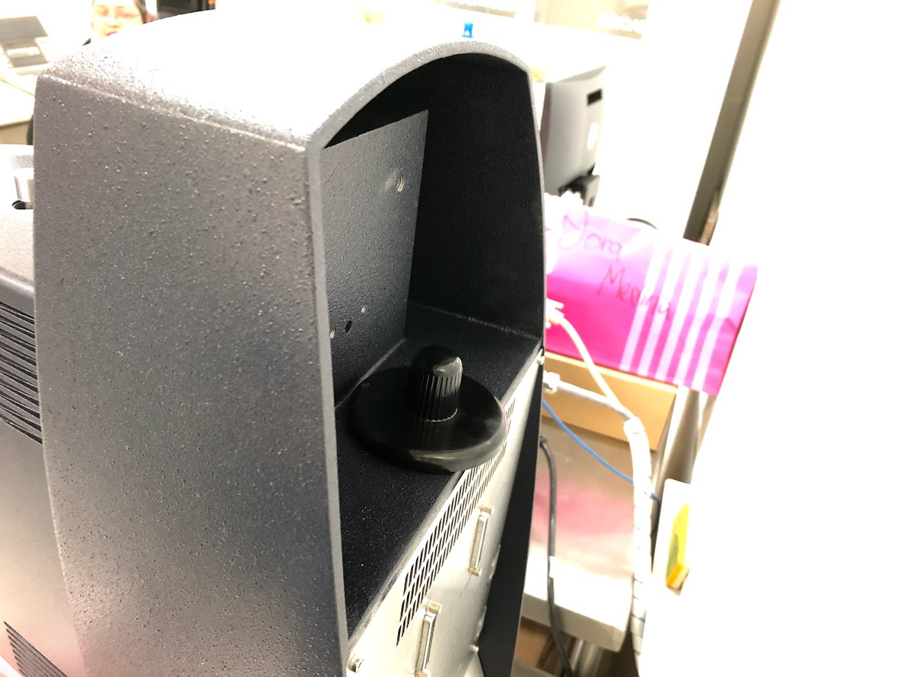

Draw rod

Bearing clamp

1. **Power** on the system by pressing the power switch on the Electronics Control Module (AKA. Electronics Box) to the On “I” position.  
     
   NOTE: If step 4 is performed before step 3, an alarm will sound and the instrument controller display will read “optical init. fail”. At this point, turn off the power and perform step 3.  
     
   The following figure illustrates the Electronics Control Module  
   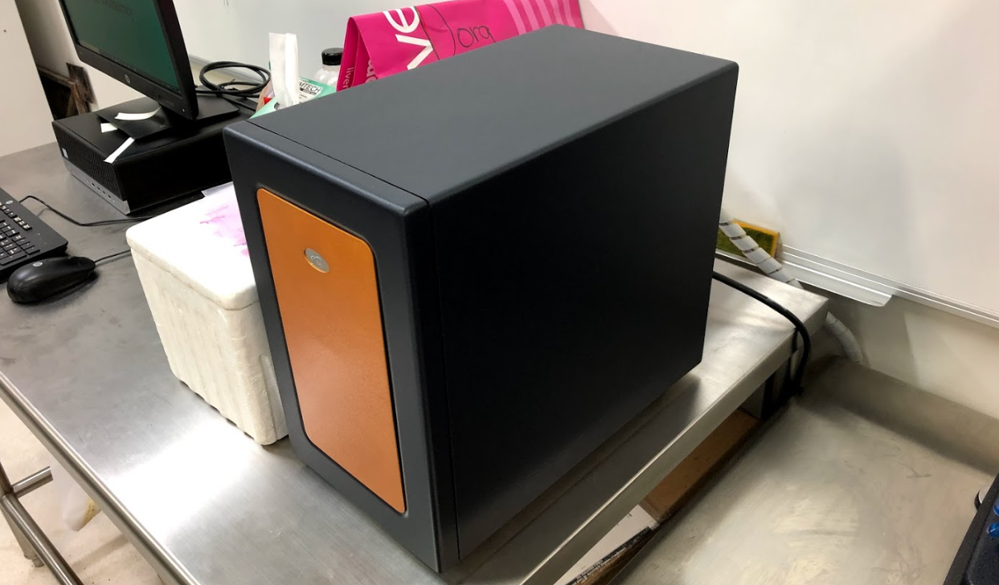  
     
   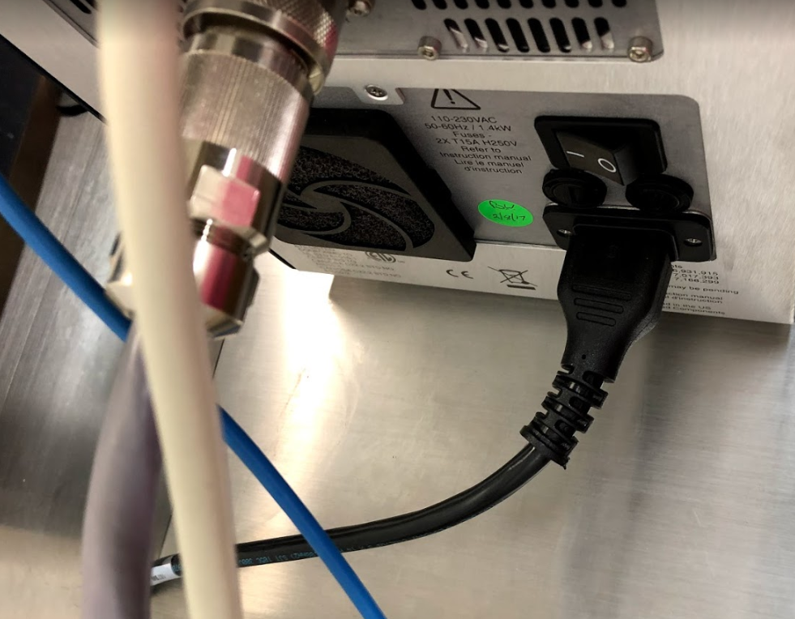

ON/OFF switch

(in its ON position)

1. **Connect** the instrument to the software.  
     
   **Turn** on the working station PC.  
   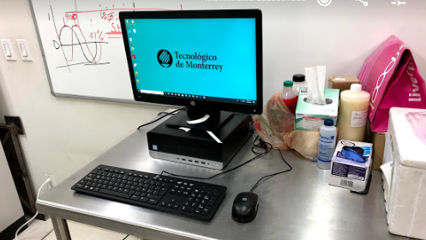  
     
   **Open** the TA instruments (TRIOS) software, by clicking on the desktop shortcut.  
   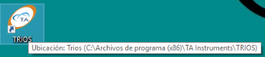

**Ensure** the TA software recognizes the instrument and **connect** to it.  
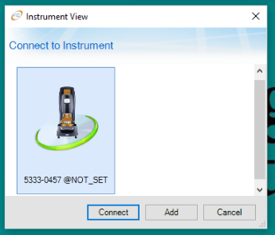

Click on “Connect” to conclude the start-up process

# Shutdown Procedure

1. **Exit** the TA instruments (TRIOS) software.
2. **Turn** off the power to the instrument by pressing the power switch on the Electronics Box (AKA. Electronics Control Module) to the Off “0” position.  
     
   The following figure illustrates the Electronics Control Module  
     
     
   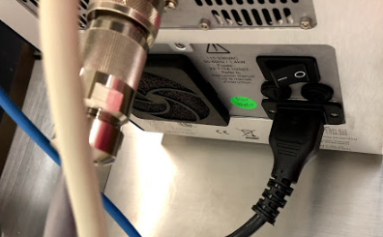

ON/OFF switch

(in its OFF position)

1. **Turn** off any fluid circulation.  
   The TA-supplied Air Cooled Circulator is located below the working table, next to the isolated ground outlet  
   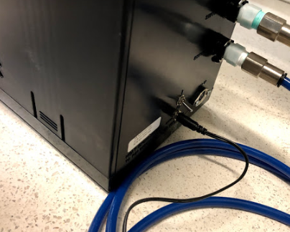  
   The switch in the DOWN position indicates the fluid circulation is OFF; similarly,  
   the switch in the UP position indicates the fluid circulation is ON.

ON/OFF switch

(in its OFF position)

1. **Fit** the bearing clamp.

**Push** the bearing clamp up the spindle and hold.  
**Rotate** the draw rod clockwise  
  
normally, the bearing clamp will be placed behind the instrument’s body.  
  
  
  
The draw rod shall pull the geometry up into position. (tight but not forced)

Draw rod

Spindle

Bearing clamp

1. **Turn** off the air supply.  
     
   **Close** the **orange** ball/T valve and then the **black** ball/T valve.  
     
   The valves in the figure above are in their open position

# Install a Geometry

1. **Ensure** the compress air supply is turned on.
2. **Ensure** the instrument is powered on and initialized.
3. **Remove** the bearing clamp by holding the clamp and turning the draw rod counter clockwise
4. **Push** the geometry up the spindle and hold.
5. **Rotate** the draw rod clockwise  
     
     
     
   The draw rod shall pull the geometry up into position. (tight but not forced)

Draw rod

Spindle

Geometry

# Install the Lower Stage

The following sections explain how to **attach** temperature modules using “Smart Swap”. The **installation** procedure is typically the same for all modules.

TIP: Make use of disposable gloves and tissue paper as some liquid may stain.  
The lower stage attachments are stored in black containers/boxes.

1. **Press** the “release button” on the control panel, as described in the figures below.  
     
   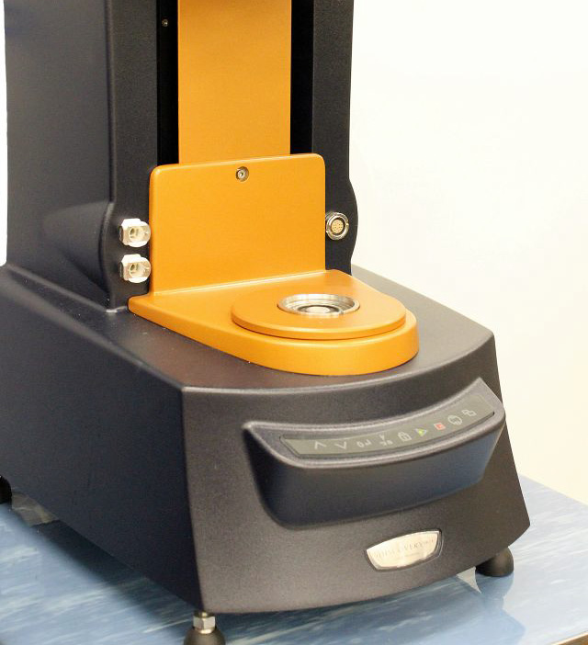  
     
   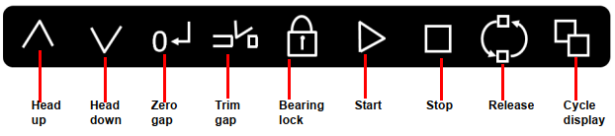  
     
   A continuous green light indicates that the attachment can be fitted.  
   **Notice** that the release state will only stay active for 10 seconds after the “release button” is pressed.

Release button

1. **Fit** the attachment as shown below.  
     
   **Ensure** the mark and slot are align.  
   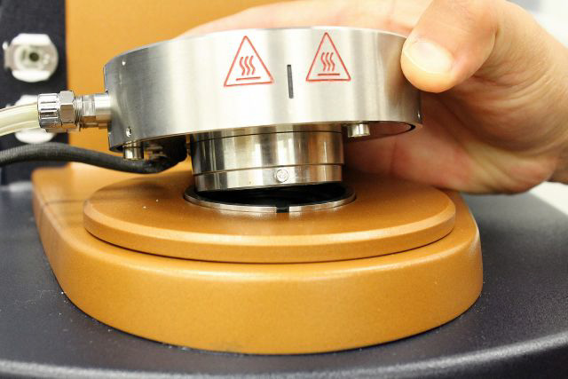  
   The installation shall fit as follows:  
   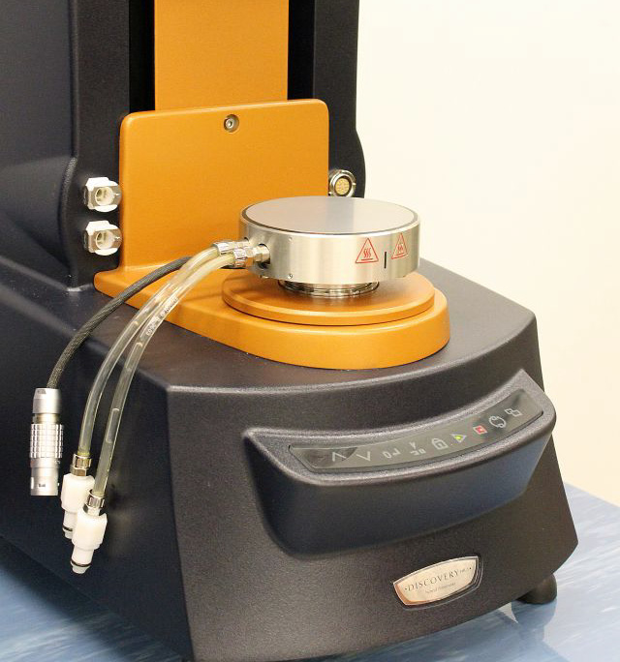

Mark

Slot

1. Connect the power cable and the fluid hoses.  
   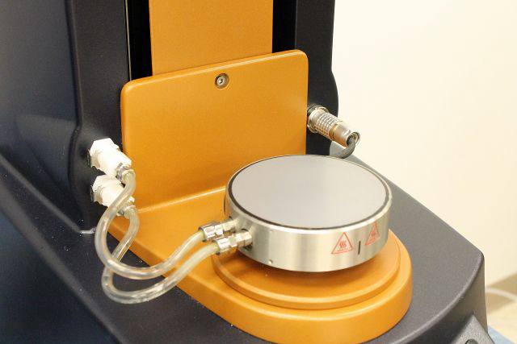

Power cable

Fluid hoses

1. **Turn** on the fluid circulation.  
   The TA-supplied Air Cooled Circulator is located below the working table, next to the isolated ground outlet  
     
   The switch in the DOWN position indicates the fluid circulation is OFF; similarly,  
   the switch in the UP position indicates the fluid circulation is ON.

ON/OFF switch

(in its OFF position)

# Remove the Lower Stage

The following sections explain how to **detach** temperature modules using “Smart Swap”. The **removal** procedure is typically the same for all modules.

TIP: Make use of disposable gloves and tissue paper as some liquid may stain

1. **Turn** off the fluid circulation.  
   The TA-supplied Air Cooled Circulator is located below the working table, next to the isolated ground outlet  
     
   The switch in the DOWN position indicates the fluid circulation is OFF; similarly,  
   the switch in the UP position indicates the fluid circulation is ON.

ON/OFF switch

(in its OFF position)

1. **Press** the “release button” on the control panel, as described in the figures below.  
     
     
     
   

Release button

1. **Disconnect** the power cable and the fluid hoses.  
   

Power cable

Fluid hoses

1. **Press** the “release button” again in the front panel.  
     
     
   **Notice** that the release state will only stay active for 10 seconds.
2. **Remove** the attachment from the instrument.
3. **Store** the removed attachment in its black container/box.

# Instrument Calibration

1. **Instrument Inertia**

**Determine** the instrument inertia by selecting under the File Manager, the *Calibration Tab* and then *Instrument*.

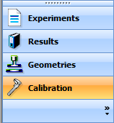 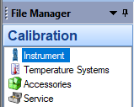

NOTE: As stated in the Figure below, **ensure** that no geometry is installed.

**Click** on “Calibrate” to start the process

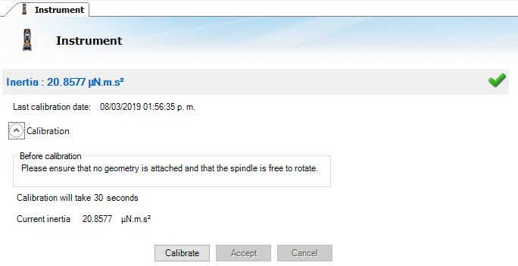

**Wait**, and **accept** the result

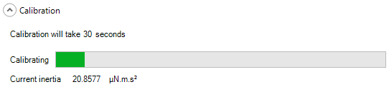

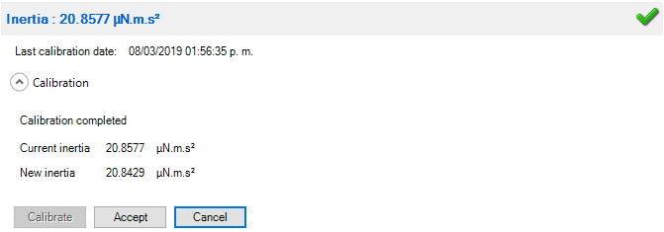

This value is unique for each bearing assembly. An acceptable range for this value is ~21µNms2 for the DHR series. The value for the instrument should not change by more than 10% of the original Inertia value.

NOTE: This calibration is recommended to be performed in monthly bases.

1. **Select a Geometry**

**Attach** a test geometry, as detailed in section “III. Install a Geometry”.

If the smart swap geometry option “smart swap enabled” is selected, the appropriate geometry file is automatically applied to your experiment.

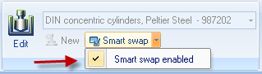

If the smart swap geometry option is disabled, choose the appropriate geometry from the list of geometry files previously created, or create a new geometry by selecting NEW, and follow the New Geometry Wizard.

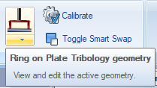 **Select** a geometry within the Geometry menu

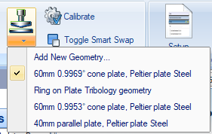 **Select** a previously created geometry file

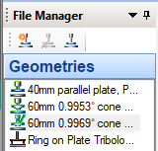

**Ensure** the selected geometry appears in the File Manager > Geometries list with a green tick.

1. **Geometry Inertia**

NOTE: The value of the inertia for each measuring system differs because they all have been uniquely engineered and have different masses. It is important to calibrate the inertia value for each geometry.

Determine the geometry inertia by **selecting** under the File Manager, the *Geometries Tab, Calibrations page* and then *Calibrate*.

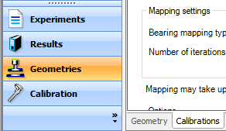

NOTE: As stated in the Figure below, **ensure** that a geometry is installed.

**Click** on “Calibrate” to start the process

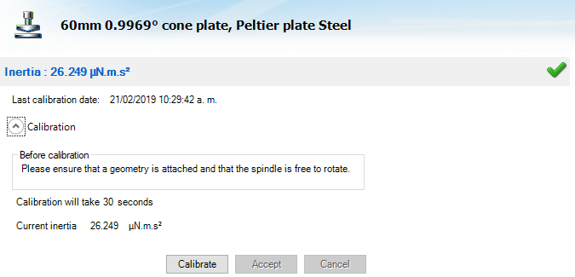

**Wait**, and **accept** the result

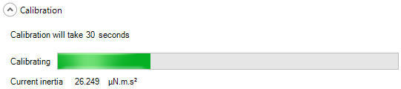

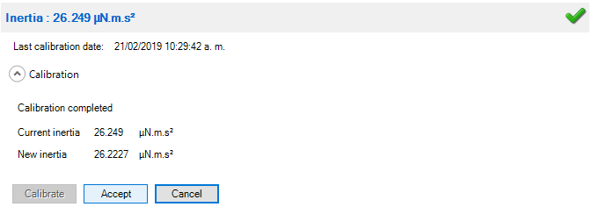

The value for the instrument should not change by more than 10% of the original Inertia value.

NOTE: This calibration is required when a new geometry file is first setup. For verification purpose, one can do it any time when changing geometry, but this is not required.

1. **Bearing Friction Correction**

A magnetic bearing is used to set the drive shaft afloat and provide virtually friction free application of torque to the sample. However, there will always be some residual friction.

With most test materials, this is insignificant, but in about 1% of the low viscosity samples, this inherent friction causes inaccuracies in the final rheological data.

Bearing friction correction can be found just below the Geometry Inertia calibration.

NOTE: As stated in the Figure below, **ensure** that the Instrument Inertia (step 1) and Geometry Inertia (step 3) have been calibrated before determining the bearing friction correction value.

**Click** on “Calibrate” to start the process

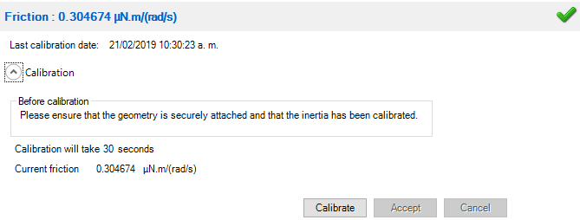

**Wait**, and **accept** the result

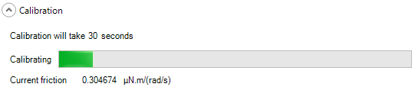

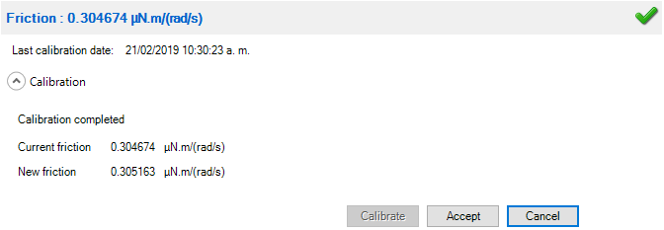

NOTE: When using a pressure cell geometry, this bearing friction value can be as high as 9 – 12 µNm/(rad/s).

NOTE: This calibration is required when a new geometry file is first setup. For verification purpose, one can do it any time when changing geometry, but this is not required.

1. **Select a System Temperature**

**Determine** the lower stage temperature by selecting under Control Panel, the *Environmental* tab.

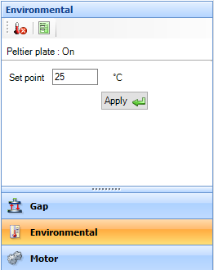

1. **Zero the Geometry Gap**

**Choose** the zero gap icon located on the Front Control Panel of the DHR,

  
  


Zero gap button

**or select** “Zero Gap” from the Control Panel and then “Apply”. Follow the directions on the screen.

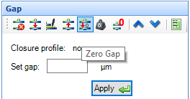

NOTE: The upper geometry should be at the testing temperature before zeroing the gap. This will account for the change in dimensions due to the coefficient of thermal expansion of the testing geometry/system.

**Wait**. The instrument’s head will move, keep the area clear of any obstacles.

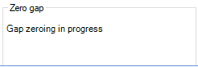

When the process is completed the following will appear, **Click** on “Yes”

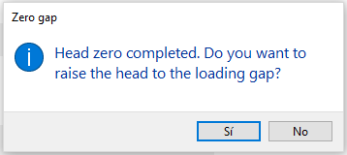

NOTE: Zero gap needs to be performed every time when the geometry is removed or replaced.

1. **Rotational Mapping**

Due to the micron-level tolerances needed to make the magnetic bearing to work, any bearing will have small variations in torque behaviour around one complete revolution of the shaft. They are consistent over time unless changes occur in the magnetic bearing.

Perform a rotational mapping on the geometry when the test procedure will be applying either a flow or transient (Creep or Stress Relaxation) mode of deformation.

**Begin** the rotational mapping by going to the Geometries Tab, Calibrations Page, and then choose Rotational Mapping.

NOTE: As stated in the Figure below, **ensure** that the geometry is installed.

**Click** on “Calibrate” to start the process

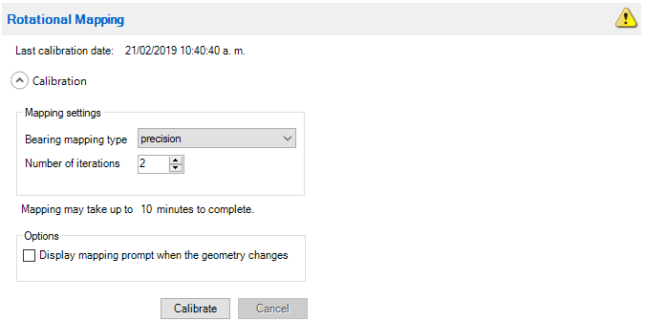

If the Head zero process has not been completed, the following will appear. **Ensure** the geometry can rotate freely and **click** on “Yes”.

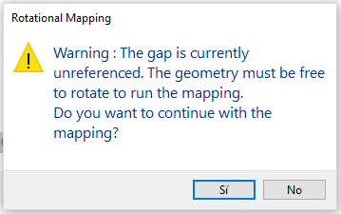

**Wait**. There are three levels of rotational mapping – fast, standard, and precision. It is also possible to perform multiple mappings iterations.

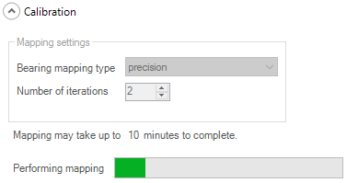

NOTE: This calibration is required when a new geometry file is first setup. The mapping history is recorded in each individual geometry file. If every time the geometry is loaded at the “home” position, there is no need for any additional mapping. But for maximum accuracy at the lower torque end of the rheometer, it is recommended that the mapping be performed each time a new measuring system is used, or if the current geometry is removed for cleaning.

# Run an Experiment

1. **Set up a Procedure**

**Create** a new procedure by selecting Procedure from the Experiments Tab,

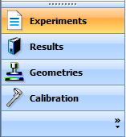

**or open** a previously created procedure by selecting the appropriate file. The procedure can be viewed, edited, and adapted in the Procedure segments.

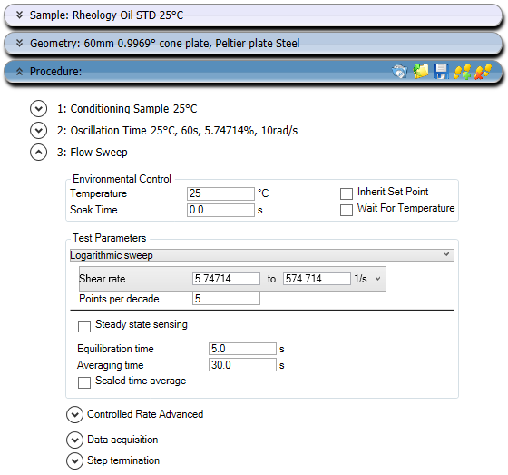

1. [Optional] **Save the Experimental File**

Select the directory/folder from File Path to save your data file. The name of the file can be the same as your sample name or others by adding more Tokens. The sample information can be entered in the Notes box.

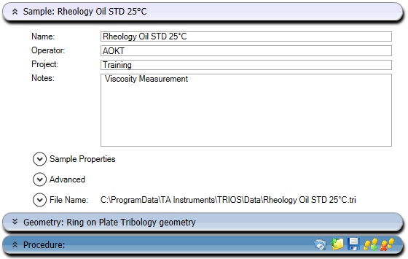

1. **Sample Loading**

The amount of sample volume that is required can vary, based on the dimensions entered in the **Select a Geometry** step for a cone, parallel plate and concentric cylinder systems.

* 1. **Gap Closure**

After loading a sample, the gap is closed by two methods.

* + 1. Manually raise or lower the gap by using the Front Control Panel arrows.

  


Rise & lower buttons

* + 1. Automatically have the instrument go to the gap value entered in the Geometry file information.

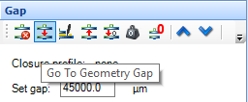

NOTE: The up and down arrows are also available in the Control Panel – Gap

* 1. **Trimming the Gap for cone or plate geometry systems**

**Load extra material and close the gap** to a value of 5% larger than the required gap, so that excess material is expelled from between the upper geometry and lower plate, i.e. overfilled state.

Then **lock the bearing** with the bearing lock button on the Front Panel in order to keep the geometry from rotating,

  


Bearing lock button

and **trim the excess material** using a right edged tool. Then lower the gap to the final test gap. The correct filling condition is shown in the following picture.

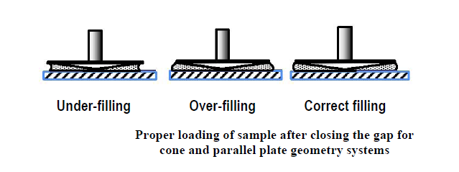

1. **Run a Test**

**Run** test by selecting the start experiment icon.

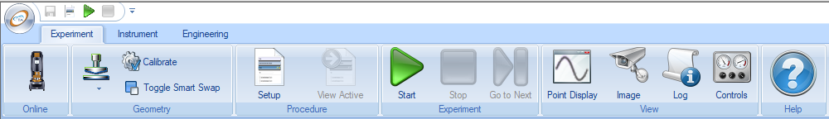

The control panel will indicate that a test is being executed, as follows:

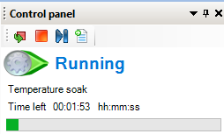

**View** the test readings by selecting Results from the Experiments Tab

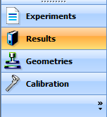

The reviewed/characterized data can be selected in the Variables menu

